

GHD-50PF | METALWORKING  Gear Head Drill Press

50000438T

400/50/3

PARTS LIST
ERSATZTEILLISTE

LISTE DE PIECES


Walter Meier (Tool) AG
Tämperlistrasse 5
CH-8117 Fällanden
Switzerland
Phone +41 44 806 47 48
Fax +41 44 806 47 58
jetinfo.eu@waltermeier.com
www.jettools.com

P-50000438T 05/09
Breakdown for the GHD-50PF
Head Assembly
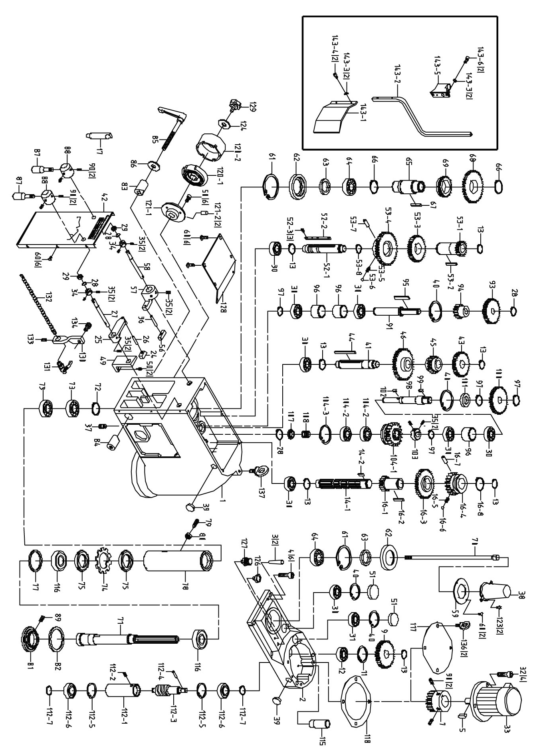

Parts List for the GHD- 50PF
Head Assembly
Index Part
No. No. Description Size Qty.
1A JMD45PF-001 Head Body Set 1
1 GHD50PF-1 Head Body 1
2 GHD50PF-2 Head Body Cover 1
3 GHD50PF-3 Miter Pin #7x50L 2
4 GHD50PF-4 Hex. Socket Head Screw M10x35L 6
5 GHD50PF-5 Key 8x7x68L 1
7 GHD50PF-6 Gear 24T 1
9 GHD50PF-9 Gear 42T 1
11 GHD50PF-11 C-Retainer Ring R47 1
12 GHD50PF-12 Bearing 6005-2RS 1
13 GHD50PF-13 C-Retainer Ring S25 7
14 GHD50PF-14 3 Speed Change Spindle Assembly (included 14-1, 14-2)" 1
14-1 GHD50PF-14-1 3 Speed Change Spindle 1
14-2 GHD50PF-14-2 Key 6x6x20L 1
16 GHD50PF-16 Gear Set assembly 22T 1
16-1 GHD50PF-16-1 Gear 22T 1
16-2 GHD50PF-16-2 Key 6x6x40L 1
16-3 GHD50PF-16-3 Gear 46T 1
16-4 GHD50PF-16-4 Gear 34T 1
16-5 GHD50PF-16-5 Spring 1
16-6 GHD50PF-16-6 Steel Ball ∮8 or 5/16" 1
16-7 GHD50PF-16-7 Spring Pin ∮5x15L 1
16-8 GHD50PF-16-8 C-Retainer Ring S35 1
17 GHD50PF-17 Chuck Arbor MT4 - B16 1
24 GHD50PF-24 Speed Change Bracket 1
25 GHD50PF-25 3 Speed Handle 1
26 GHD50PF-26 Spring Pin ∮5x30L 1
27 GHD50PF-27 Long Speed Change Handle 1
28 GHD50PF-28 C-Retainer Ring S15 4
29 GHD50PF-29 Oil Seal 15x25x7t 2
30 GHD50PF-30 Bearing 6004ZZ 8
31 GHD50PF-31 Bearing 6004 1
32 GHD50PF-32 Hex. Socket Head Screw M12x35L 4
33 GHD50PF-33AE Motor(4HP/400V/50HZ/3PH 4p) 1
34 GHD50PF-34 Lock nut 2
35 GHD50PF-35 Hex. Socket Headless Screw M6x8L 10
36 GHD50PF-36 Spring Pin ∮4x20L 1
37 GHD50PF-37 Hex. Socket Headless Screw PT1/4"X11L 1
38 GHD50PF-38 Main Shaft Cover 1
39 GHD50PF-39 Fluid Lever Indicator M30 2
40 GHD50PF-40 C-Retainer Ring R42 4
41 GHD50PF-41 Driven Spindle 1
42 GHD50PF-42 Name Plate 1
43 GHD50PF-43 Gear 38T 1
44 GHD50PF-44 Key 6x6x80L 1
45 GHD50PF-45 Gear 26T 1
46 GHD50PF-46 Gear 50T 1
49 GHD50PF-49 Handle Support 1
50 GHD50PF-50 Hex. Socket Head Screw M6x20L 8
51 GHD50PF-51 Cover 2
52 GHD50PF-52 High - Low Speed Spindle assembly 1
52-1 GHD50PF-52-1 High - Low Speed Spindle 1
52-2 GHD50PF-52-2 KEY 1
52-3 GHD50PF-52-3 Hex. Socket Head Screw 3
53 GHD50PF-53 Gear Set assembly 22T 1
53-1 GHD50PF-53-1 Gear 22T 1
53-2 GHD50PF-53-2 Key 6x6x40L 1
53-3 GHD50PF-53-3 Gear 40T 1
Index Part
No. No. Description Size Qty.
53-4 GHD50PF-53-4 Gear 52T 1
53-5 GHD50PF-53-5 Spring 1
53-6 GHD50PF-53-6 Steel Ball ∮8 or 5/16" 1
53-7 GHD50PF-53-7 Spring Pin ∮5x15L 1
53-8 GHD50PF-53-8 C-Retainer Ring S35 1
56 GHD50PF-56 Speed Change Bracket 1
57 GHD50PF-57 High - Low Speed Handle 1
58 GHD50PF-58 Short Speed Change Handle 1
59 GHD50PF-59 Outer Bearing Plate 1
60 GHD50PF-60 Hex. Socket Head Screw M6x10L 14
61 GHD50PF-61 C-Retainer Ring R100 2
62 GHD50PF-62 Oil Seal Ring 2
63 GHD50PF-63 Oil Seal 55x75x10t 2
64 GHD50PF-64 Bearing 6211-2RS 2
65 GHD50PF-65 Spindle Taper Sleeve 1
66 GHD50PF-66 C-Retainer Ring S65 2
67 GHD50PF-67 Key 8x8x45L 1
68 GHD50PF-68 Gear 78T 1
69 GHD50PF-69 Gear 48T 1
70 GHD50PF-70 Chuck Arbor Bolt MT4 M16x560L 1
71 GHD50PF-71 Spindle Shaft MT4 1
72 GHD50PF-72 C-Retaniner Ring S40 1
73 GHD50PF-73 Bearing 6008ZZ 2
74 GHD50PF-74 Washer AW10 1
75 GHD50PF-75 Nut AN10 2
77 GHD50PF-77 Bushing 1
78 GHD50PF-78 Rack Sleeve MT4 1
79 GHD50PF-79 Screw Key 3/8" 1
80 GHD50PF-80 Hex. Nut 3/8" 1
81 GHD50PF-81 Bearing Cap 1
82 GHD50PF-82 Rubber Flange ∮100x∮120x8t 1
83 GHD50PF-83 Head Lock (Front) 1
84 GHD50PF-84 Head Lock (Back) 1
85 GHD50PF-85 Handle Rod 1
86 GHD50PF-86 Washer M12 1
87 GHD50PF-87 Speed Change Handle 2
88 GHD50PF-88 Speed Lever 2
89 GHD50PF-89 Hex. Socket Headless Screw M5x5L 1
90 GHD50PF-90 Hex. Socket Headless Screw M8x10L 6
91 GHD50PF-91 PF Driven Spindle 1
93 GHD50PF-93 Gear 34T 1
94 GHD50PF-94 Gear 18T 1
95 GHD50PF-95 Key 5x5x50L 1
96 GHD50PF-96 Bushing 3
97 GHD50PF-97 C-Retainer Ring S20 4
98 GHD50PF-98 PF Transmission Spindle 1
99 GHD50PF-99 Key 5x5x15L 1
100 GHD50PF-100 Gear 42T 1
101 GHD50PF-101 Oil Seal 25x42x8t 1
102 GHD50PF-102 Key 5x5x10L 1
103 GHD50PF-103 Clutch Block 1
104 GHD50PF-104 Gear Set 30T 1
104-1 GHD50PF-104-1 Gear 30T 1
104-2 GHD50PF-104-2 Bearing 6002ZZ 2
104-3 GHD50PF-104-3 C-Retainer Ring R32 1
107 GHD50PF-107 Bushing 1
108 GHD50PF-108 Spring ∮1.5x∮18x23L 1
112 GHD50PF-112 Oil Feeding Tube Assembly 1
112-1 GHD50PF-112-1 Oil Feeding Tube 1
112-2 GHD50PF-112-2 Hex. Socket Headless Screw M8x10L 1
Index Part
No. No. Description Size Qty.
112-3 GHD50PF-112-3 Oil Feeding Spindle 1
112-4 GHD50PF-112-4 Spring Pin ∮5x30L 1
112-5 GHD50PF-112-5 C-Retainer Ring R28 2
112-6 GHD50PF-112-6 Bearing 6001 2
112-7 GHD50PF-112-7 C-Retainer Ring S12 2
115 GHD50PF-115 Oil Returning Tube 1
116 GHD50PF-116 Bearing 7010AW 2
117 GHD50PF-117 Motor Plate 1
118 GHD50PF-118 Gear Box Gasket 1
120 GHD50PF-120 Spring & Spring Cover Set 1
120-1 GHD50PF-120-1 Spring 1
120-2 GHD50PF-120-2 Spring Cover 1
121 GHD50PF-121 Spring Base Set 1
121-1 GHD50PF-121-1 Spring Base 1
121-2 GHD50PF-121-2 Spring Pin ∮3x15L 2
123 GHD50PF-123 Cross Round Head Screw M5x10L 2
124 GHD50PF-124 Washer M8 1
126 GHD50PF-126 Oil Hole Plug M16xP1.5x8L 1
127 GHD50PF-127 Vent Plug PT1/8" 1
128 GHD50PF-128 Bottom Plate 1
129 GHD50PF-129 Lock knob 1
130 GHD50PF-130 Nozzle Cock Support 1
131 GHD50PF-131 Valve 1/4' 1
132 GHD50PF-132 Nozzle 1/4" 1
133 GHD50PF-133 Hex. Socket Headless Screw M6x8L 1
134 GHD50PF-134 Hex. Socket Head Screw M8x16L 1
136 GHD50PF-136 Flying Rings M12 2
137 GHD50PF-137 Flying Rings M16 1
143 GHD50PF-143 Chuck Guard Assembly 1
143-1 GHD50PF-143-1 Chuck Guard 1
143-2 GHD50PF-143-2 Chuck Guard Supporting Rod 1
143-3 GHD50PF-143-3 Spring Washer M5 4
143-4 GHD50PF-143-4 Hex. Socket Head Screw M5x10L 2
143-5 GHD50PF-143-5 Rotary Supporting Base(For CE Only) 1
143-6 GHD50PF-143-6 Hex. Socket Head Screw M5x15L 2

Breakdown for the GHD-50PF
Transmission Assembly
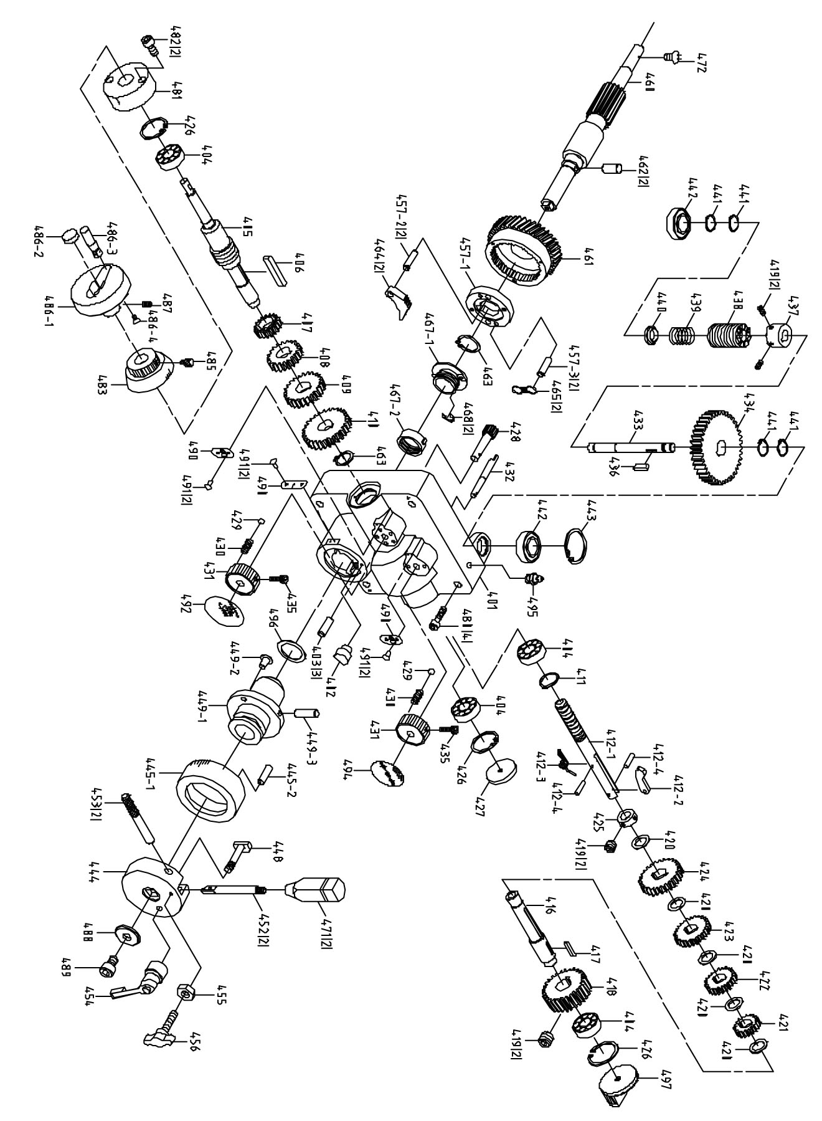

Parts list for the GHD-50PF
Transmission Assembly
Index Part
No. No. Description Size Qty.
401 GHD50PF-401 Gear Box 1
402 GHD50PF-402 Release Block 1
403 GHD50PF-403 Pin ∮4x13L 3
404 GHD50PF-404 Bearing 6004ZZ 4
405 GHD50PF-405 Transmission Worm Shaft 1
406 GHD50PF-406 Key 5x5x45L 1
407 GHD50PF-407 Gear 20T 1
408 GHD50PF-408 Gear 24T 1
409 GHD50PF-409 Gear 30T 1
410 GHD50PF-410 Gear 40T 1
411 GHD50PF-411 C-Retainer Ring S20 1
412 GHD50PF-412 Change Gear Lever Set 1
412-1 GHD50PF-412-1 Change Gear Lever 1
412-2 GHD50PF-412-2 Speed-Changing Key 1
412-3 GHD50PF-412-3 Twisted Spring 1
412-4 GHD50PF-412-4 Spring Pin ∮3x10L 2
416 GHD50PF-416 Shaft 1
417 GHD50PF-417 Key 5x5x25L 1
418 GHD50PF-418 Worm Shaft 1
419 GHD50PF-419 Hex. Socket Headless Screw M6x8L 6
420 GHD50PF-420 Bushing 5
421 GHD50PF-421 Gear 20T 1
422 GHD50PF-422 Gear 30T 1
423 GHD50PF-423 Gear 36T 1
424 GHD50PF-424 Gear 40T 1
425 GHD50PF-425 Bushing Bracket 1
426 GHD50PF-426 C-Retainer Ring R42 3
427 GHD50PF-427 Cover 1
428 GHD50PF-428 Gear Shaft 1
429 GHD50PF-429 Steel Ball ∮8 or 5/16" 2
430 GHD50PF-430 Spring 2
431 GHD50PF-431 Speed Lever 2
432 GHD50PF-432 Clutch Spindle 1
433 GHD50PF-433 Clutch Worm Shaft Spindle 1
434 GHD50PF-434 Gear 35T 1
435 GHD50PF-435 Hex. Socket Head Screw M5x20L 2
436 GHD50PF-436 Key 5x5x30L 1
437 GHD50PF-437 Reverse Clutch 1
438 GHD50PF-438 Worm Shaft 1
439 GHD50PF-439 Spring 1
440 GHD50PF-440 Bushing 1
441 GHD50PF-441 C-Retainer Ring S15 4
442 GHD50PF-442 Bearing 6202ZZ 2
443 GHD50PF-443 C-Retainer Ring R35 1
444 GHD50PF-444 Handle Body 1
445 GHD50PF-445 Scale Base 1
445-1 GHD50PF-445-1E Scale Base Metric 1
445-2 GHD50PF-445-2 Pin 1
448 GHD50PF-448 Scale Base Set Screw 1
449 GHD50PF-449 Clutch Bushing Set 1
449-1 GHD50PF-449-1 Clutch Bushing 1
449-2 GHD50PF-449-2 Bushing Stop 1
449-3 GHD50PF-449-3 Bushing Pin 1
452 GHD50PF-452 Handle Rod 2
453 GHD50PF-453 Handle Rod Pin 2
454 GHD50PF-454 Graduated Base Fixed Grip 1
455 GHD50PF-455 Hex. Nut 5/16" 1
456 GHD50PF-456 T Screw 1
Index Part
No. No. Description Size Qty.
457 GHD50PF-457 Clutch Key Base Set 1
457-1 GHD50PF-457-1 Clutch Key Base 1
457-2 GHD50PF-457-2 Clutch Key Pin 2
457-3 GHD50PF-457-3 Spring Pin 2
460 GHD50PF-460 Pinion Shaft 1
461 GHD50PF-461 Worm Gear 1
462 GHD50PF-462 Key 2
463 GHD50PF-463 C-Retainer Ring S25 2
464 GHD50PF-464 Clutch Key 2
465 GHD50PF-465 Spring 2
467 GHD50PF-467 Clutch Screw Set 1
467-1 GHD50PF-467-1 Clutch Screw 1
467-2 GHD50PF-467-2 Clutch Nut 1
468 GHD50PF-468 E- Retaining Ring E5 2
471 GHD50PF-471 Knob 2
472 GHD50PF-472 Flat Cross Head Screw M6x10L 1
480 GHD50PF-480 Hexagon screw M8x100L 4
481 GHD50PF-481 Worm Cover 1
482 GHD50PF-482 Cross Round Head Screw M5x25L 2
483 GHD50PF-483E Micro Adjusting Indicator Metric 1
485 GHD50PF-485 Link Screw 1/4"x12L 1
486 GHD50PF-486 Wheel 1
486-1 GHD50PF-486-1 Wheel 1
486-2 GHD50PF-486-2 Cover 1
486-3 GHD50PF-486-3 Foldable handle bar 1
486-4 GHD50PF-486-4 Hex. Socket Head Screw M6x10L 1
487 GHD50PF-487 Hex. Socket Headless Screw M8x10L 1
488 GHD50PF-488 Washer M8 1
489 GHD50PF-489 Hexagon screw M8x15L 1
490 GHD50PF-490 Scale 3
491 GHD50PF-491 Rivet ∮2x4L 6
492 GHD50PF-492E Feeding Speed Label Metric 1
494 GHD50PF-494 Clutch Label 1
495 GHD50PF-495 Grease Nipple PT1/8" 1
496 GHD50PF-496 Washer 1.5t 1
497 GHD50PF-497 Cover 1

Breakdown for the GHD-50PF
Base and Table Assembly

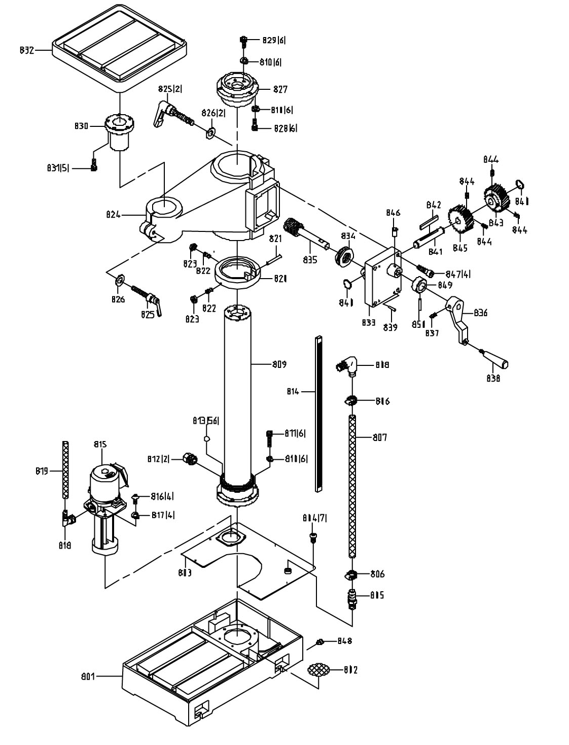

Parts list for the GHD-50PF
Base and Table Assembly
Index Part
No. No. Description Size Qty.

801 GHD50PF-801 Swivel Base 1
802 GHD50PF-802 Filter 1
803 GHD50PF-803 Coolant Pump Cover 1
804 GHD50PF-804 Hex. Socket Head Screw M6x10L 7
805 GHD50PF-805 Pipe Connector 1/2PT 1
806 GHD50PF-806 Hose Clip 1/2PT 2
807 GHD50PF-807 Hose ∮3/4"×∮27×1250L 1
808 GHD50PF-808 Angle Valve 90° 1/2PT×3/4" 1
809 GHD50PF-809 Column Base 1
810 GHD50PF-810 Spring Washer M16 18
811 GHD50PF-811 Hexagon screw M16x65L 6
812 GHD50PF-812 Cable Connector PG13.5 2
813 GHD50PF-813 Steel Ball ∮10 56
814 GHD50PF-814 Rack 1
815 GHD46PF-807AE Coolant Pump 400V,3Ph 1
816 GHD50PF-816 Cross Round Head Screw M4x25L 4
817 GHD50PF-817 Spring Washer M4 4
818 GHD50PF-818 Coupler PT3/8"x5/16"L 90° 1
819 GHD50PF-819 Hose 1/4"×∮11×1400L 1
820 GHD50PF-820 Bearing Cover 1
821 GHD50PF-821 Spring Pin ∮6x60L 1
822 GHD50PF-822 Hex. Socket Headless Screw M8x30L 2
823 GHD50PF-823 Hex. Nut M8 2
824 GHD50PF-824 Square Table Base 1
825 GHD50PF-825 Knob M12×60 3
826 GHD50PF-826 Washer ∮13.2x∮28xt3 3
827 GHD50PF-827 Connect Base 1
828 GHD50PF-828 Hexagon screw M16x55L 6
829 GHD50PF-829 Hexagon screw M16x55L 6
830 GHD50PF-830 Table Connect Shaft 1
831 GHD50PF-831 Hexagon screw M12x40L 5
832 GHD50PF-832 Square Table 1
833 GHD50PF-833 Head Raise Bracket 1
834 GHD50PF-834 Bearing 51204 1
835 GHD50PF-835 Worm Shaft 1
836 GHD50PF-836 Up-Down Handle 1
837 GHD50PF-837 Hex. Socker Headless Screw M8x15L 1
838 GHD50PF-838 Knob 1
839 GHD50PF-839 Spring Pin ∮6x50L 2
840 GHD50PF-840 C-Retaniner Ring ∮20 2
841 GHD50PF-841 Worm Shaft 1
842 GHD50PF-842 Key 6x6x75L 1
843 GHD50PF-843 Worm Gear 1
844 GHD50PF-844 Hex. Socker Headless Screw M8x10L 4
845 GHD50PF-845 Worm Gear 2
846 GHD50PF-846 Oil Ball 1
847 GHD50PF-847 Hexagon screw M8x50L 4
848 GHD50PF-848 Plug PT1/2 1
849 GHD50PF-849 Bushing 1
850 GHD50PF-850 Pin 1

Break down for the GHD-50PF
Electrical Box Assembly

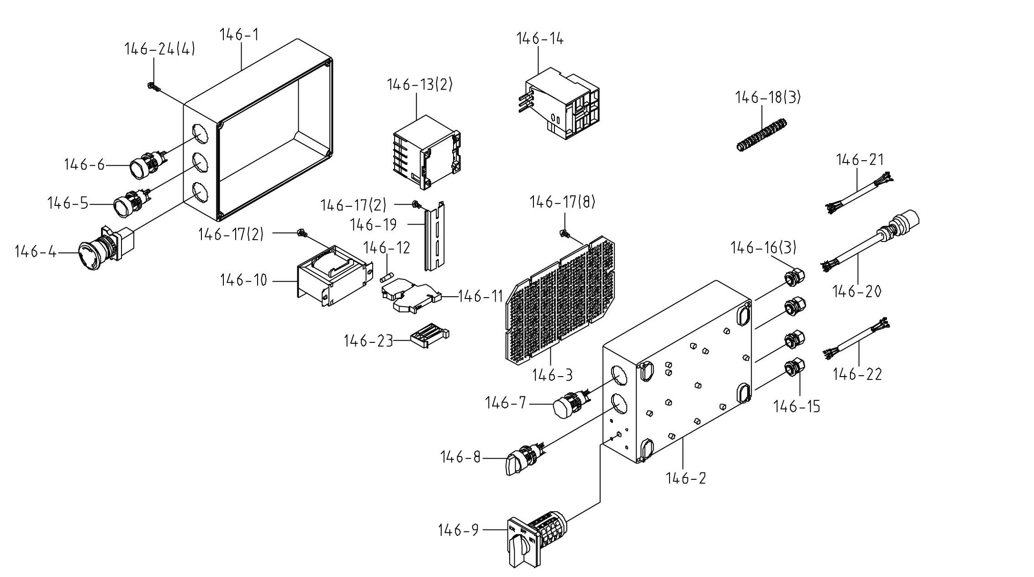
Parts list for the GHD-50PF
Electrical Box Assembly

Index Part
No. No. Description Size Qty.
146A GHD50PF-146A Control Box Assembly 1
146-1 GHD50PF-146-1 Box Upper Lib 1
146-2 GHD50PF-146-2 Box Seat 1
146-3 GHD50PF-146-3 Net-Pin 1
146-4 GHD50PF-146-4 Emergency-Stop Switch HY-57B 1
146-5 GHD50PF-146-5 Push-Button Switch NPB-R1b 1
146-6 GHD50PF-146-6 Push-Button Switch NPB-1G1a 1
146-7 GHD50PF-146-7 Lamp 1
146-8 GHD50PF-146-8 Pump Choice-Switch NSS-22S2 1
146-9 GHD50PF-146-9 Switch 1
146-10 GHD50PF-146-10 Transformer 1
146-11 GHD50PF-146-11 Fuse (Base) KLEMSAN ASK25X20 1
146-12 GHD50PF-146-12 Fuse 1A 2CM 1
146-13 GHD50PF-146-13 Magnetic Contactor C-06D10A7 2
146-14 GHD50PF-146-14 Over-Load 10K 5.5-8.5A 1
146-15 GHD50PF-146-15 Cable-Gland PG-11 1
146-16 GHD50PF-146-16 Coupler 3/8" 3
146-17 GHD50PF-146-17 Screw 3/16"x3/8"L 12
146-18 GHD50PF-146-18 Hose 3/8" 3
146-19 GHD50PF-146-19 Din-Rails 35MM *9CM 1
146-20 GHD50PF-146-20 Power cable VDE 1.5x4C 1
146-21 GHD50PF-146-21 Motor Cable VDE 1.5*4C 1
146-22 GHD50PF-146-22 Pump Cable VDE0.75*4C 1
146-23 GHD50PF-146-23 End-Gland 1
146-24 GHD50PF-146-24 Cross Round Head Screw M4x15L 4

GHD-50PF 400/50/3

50000438T
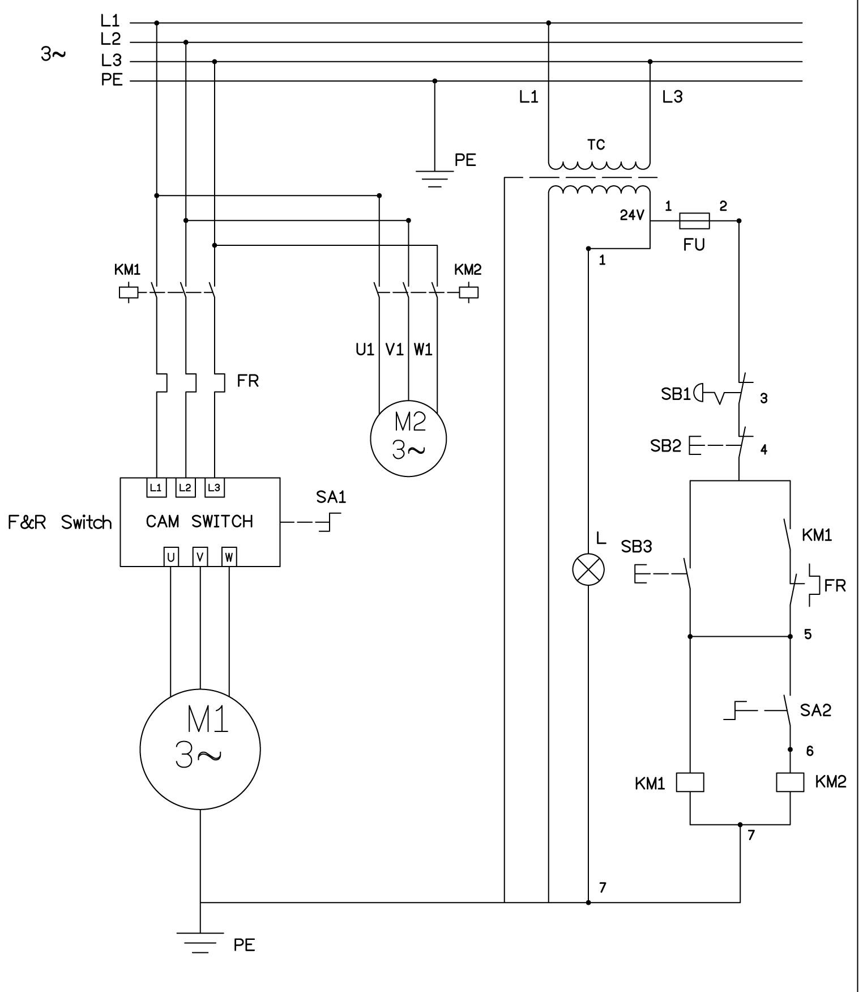
 | colour of strands | Litzenfarben | couleur des cordons
BK | black | schwarz | noir
BU | blue | blau | bleu
BN | brown | braun | brun
GY | grey | grau | gris
GNYE | green-yellow | grün-gelb | vert-jaune

 | meaning of symbol | Bedeutung der Zeichen | interprétation
M | main motor | Hauptmotor | moteur principal
L | indicator lamp | Anzeigelampe | lampe d´indication
SB1 | emergency stop switch | Not-Aus Schalter | arrêt d'urgence
SB2 | off switch | Aus-Schalter | bouton arrêt
SB3 | start switch | Ein-Schalter | bouton marche
KM1 | contactor for main motor | Hauptschütz | contacteur moteur
KM2 | contactor for coolant pump | Kühlmittel Hauptschütz | contacteur pompe
F | fuse | Sicherung | fusible
L | work lamp | Maschinenleuchte | lampe
FR | overload cut-off | Überlastschutz | interrupteur surcharge
TC | transformer | Transformator | transformateur
SA1 | F/R switch | Schalter Rechtslauf | bouton a droite
SA2 | pump switch | Kühlmittel-Schalter | commutateur pompe

